**Making predictions with matrix multiplication**

In later chapters, you will learn to train linear regression models. This process will yield a vector of parameters that can be multiplied by the input data to generate predictions. In this exercise, you will use input data, features, and a target vector, bill, which are taken from a credit card dataset we will use later in the course.

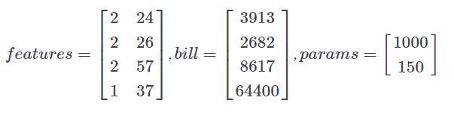

The matrix of input data, features, contains two columns: education level and age. The target vector, bill, is the size of the credit card borrower's bill.

Since we have not trained the model, you will enter a guess for the values of the parameter vector, params. You will then use matmul() to perform matrix multiplication of features by params to generate predictions, billpred, which you will compare with bill. Note that we have imported matmul() and constant().

##### Instructions

**100 XP**

* Define features, params, and bill as constants.
* Compute the predicted value vector, billpred, by multiplying the input data, features, by the parameters, params. Use matrix multiplication, rather than the element-wise product.
* Define error as the targets, bill, minus the predicted values, billpred.

# Define features, params, and bill as constants

features = constant([[2, 24], [2, 26], [2, 57], [1, 37]])

params = constant([[1000], [150]])

bill = constant([[3913], [2682], [8617], [64400]])

# Compute billpred using features and params

billpred = matmul(features, params)

# Compute and print the error

error = bill - billpred

print(error.numpy())

Nice job! Understanding matrix multiplication will make things simpler when we start making predictions with linear models.